Dinosaur Hill Coming to Kingsbury
This Photo by Unknown Author is licensed under CC BY

Mr. Joel will present hands-on activities to demonstrate
the life cycle, food chain, and much more about plants and animals.

3rd grade Field Trip (during class)
Wednesday, May 30th

The cost will be $5 per student
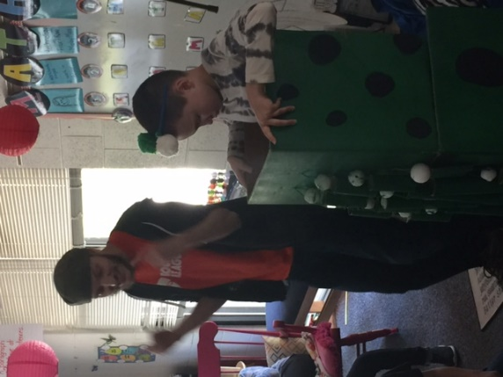
Due by Tuesday, May 29
